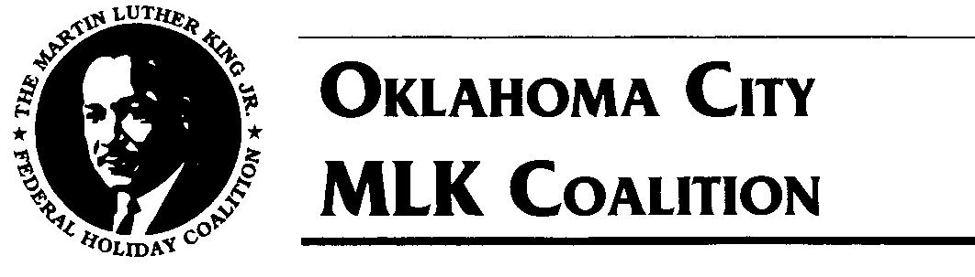

November 1, 2021

Dear Parade Participants/Sponsors:

**January 17, 2022** is the date for the **2022 King Holiday Events**. Last year because of the Corona virus we held “Virtual Events and Parade”, which we felt was a great success with thousands of views online but nothing like the real thing. Well this year we will be back to live events!!! In hope of having thousands of patrons line the streets to watch once more. The King Holiday Events and Parade continues to bring us together as a sign of UNITY and a demonstration of keeping the dream alive.

Our 2022 theme, “**Resilient and Relentless**” showing how together we are capable of withstanding the many challenges we faced over the last year, including “Covid”. We have always and will continue to display the virtues that will honor Dr. King’s life and work! We ask that every entry incorporate the theme of the day.

The corona virus has slowed down but it is still here. Therefore, we will follow the CDC guidelines and requirements by making changes and adjustments in how we gather and celebrate. Because of the new normal, the 2022 Dr. Martin Luther King, Jr. holiday activities hosted by the MLK Coalition will follow the guidelines at the time of the events, so we ask that everyone be ready to make any needed changes. As we continue the celebration of the life and legacy of Rev. Dr. Martin Luther King, Jr. We have listed below the guidelines that must be followed for our Celebration. It includes various ways your organization can join with the MLK Coalition and other partners to celebrate the life and legacy of Dr. King Jr. We respect your work and your efforts and look forward to your continued support and participation in the celebration.

Join us for a live Job Fair, Silent March, Bell Ringing, Program, and Parade. Directions and information on how this will take place will be in the packet and on our website.

Enclosed is the 2022 King Holiday Parade Registration Form**.** All participants must register and be approved to participate.

**Registration Fees** = $45.00

**Late Registration Fees =** $55.00

**Registration Deadlines *(Mail-In Registrations -OR- On-line Registrations)***

Registration Deadline: January 7, 2022 by 5 pm

Late Registration Deadline: January 10, 2022 after 5 pm

NO registrations accepted after January 11, 2022

**You can complete registration forms & pay entry fees online: okcmlkcoalition.org**

Mail Registration Forms along with Checks/Money Orders payable to:

**OKCMLK Coalition, P.O. Box 53084, Okla. City, OK 73152**

**R. L. Doyle**

Chair

(405) 413-4372

**Roosevelt Milton**

Vice Chair

(405) 427-1972

(405) 308-1472

**Winard Brown**

Treasurer

(405) 410-7740

**William Jones**

Events Coordinator

(405) 306-8440

**Garland Pruitt**

Parade

Co-Coordinator

(405) 473-6152

**Diana Johnson**

**Latosha Lornes**

Public Relation

(405) 255-6201

**Rebecca Ross**

Volunteer

Coordinator

(405) 761-5656

**Denise Hyche**

Job Fair Coordinator

(405) 596-5411

**LaVet Richmond**

# Essay/Poster

Coordinator



**Website: okcmlkcoalition.org • Facebook: https://www.facebook.com/okcmlk**

**Oklahoma City MLK Coalition** • **P.O. Box 53084 • Oklahoma City, OK 73152 • (405) 413-4372**

**Dr. Martin Luther King, Jr. Holiday Parade**

2022 OKCMLK Holiday Coalition

Page 2

If you have any questions or need additional information, please contact Events Coordinator, **William Jones (405) 306-8440** or **Garland Pruitt (405) 473-6152**. We also invite you to visit our web site at [www. okcmlkcoalition.org.](http://www.okcmlk.org)  Again, thank you for your continued participation and support for our organization. You are vital to the overall success and purpose of the OKC MLK Holiday Parade.

Sincerely yours,

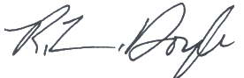

R. L. Doyle, Chair

MLK Holiday Coalition

Enclosures

**MONDAY, JANUARY 17, 2022 •** 2022 Theme: **“Resilient and Relentless”**

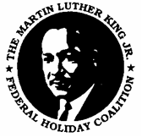**2022** Dr. Martin Luther King, Jr. Holiday Celebration

**PARADE REGISTRATION**

***$45.00 - Registration Deadline:*** *January 7, 2022*

***$55.00 - Late Registration Deadline:*** *January 10, 2022 after 5 pm*

***No registrations accepted after January 11, 2022***

**ABSOLUTELY NO ON-SITE REGISTRATION!!** Visit our website at okcmlkcoalition.org to register on-line.

Organization Name:

Contact Person:

Day Phone: Cell Phone: Evening Phone:

Fax #: Email:

Address: City/State/Zip:

**Please make Checks/Money Orders payable to: OKCMLK Coalition**

**All Entry Fees Are Non- Refundable**

** $ 45.00 NON –VENDOR INDIVIDUAL GROUP**

** $ 45.00 CAR CLUBS (5 VEHICLE LIMIT) Per Registration**

** $ 45.00 MOTORCYLE CLUB (10 BIKE LIMIT) Per Registration**

** $ 45.00 HORSE CLUB (15 HORSE LIMIT) Per Registration**

** NO FEE FOR MIDDLE/HIGH SCHOOL BAND OR ROTC**

**TYPE OF ENTRY: (Check One)**

** Cars/ Limousine**

** Float (overall length of float & towing vehicle):______________ feet**

** /Other Musical Entertainment ______________________**

** Drill Team/Color Guard/Twirling Corp/Military**

** Royalty/Beauty Queen/Mascot**

** Equestrian Unit/Riding Club/Horse Drawn Equipment**

** Marching Unit/Youth Group/Scout Group/Church Group**

** All Others: Clown/Fire Truck/Car Club/Motorcycle Club**

** Middle/High School Band or ROTC (Free but must register)**

**DETAILED ENTRY DESCRIPTION please let us know about any other info that will help with placement. ____________________________________________________________________________________________**

**____________________________________________________________________________________________**

# For more information, please email the MLK Coalition at okcmlk@gmail.com or visit our website at okcmlkcoalition.org.

**Waiver of Liability:** In consideration of the acceptance of this entry, the above-named entrant intends to be legally bound, waives and releases any and all OKCMLK Holiday Parade or OKCMLK Coalition sponsors, board members, staff, volunteers, and any co-sponsors or their respective representatives from any and all rights and claims for damages arising out of any accident, injuries, or illnesses suffered in this event regardless of how such may arise and even if such is caused by negligence of those parties. Furthermore, full permission is granted to any and all of the aforementioned to use names, photographs, videotapes, and any recordings of anyone participating in this event for any purposes without obligation or liability to the Coalition.

Signature of Parade Participant/Sponsoring Organization Representative Date

AMOUNT ENCLOSED: $________________________________________

**2022** Dr. Martin Luther King, Jr. Holiday Celebration

**SPONSORSHIP APPLICATION**

**Company Name: ______________________________________________________________**

**Contact Person________________________________________________________________**

**Address: _____________________________________________________________________**

**Phone: __________________________________Fax: ________________________________**

**Email Address: ______________________________________________________**

**_____ We would like to find out more about Corporate Sponsorship opportunities. Please have a representative contact me.**

**_____ Yes, my company would like to sponsor the following event(s): Select One**

**□ $5,000 = Platinum Level Event Sponsor □ $ 500 = Bronze Level Benefactor**

**□ $3,000 = Gold Level Event Sponsor □ $ 125 = Contributor to MLK Holiday Coalition**

**□ $1,000 = Silver Level Benefactor**

|  |  |  |  |  |  |
| --- | --- | --- | --- | --- | --- |
| **Benefits** | **Platinum**  **$5,000** | **Gold**  **$3,000** | **Silver**  **$1,000** | **Bronze $500** | **Contributor**  **$125** |
| *Most prominent name and logo placement on all printed materials related to event (i.e. Invitation, T-shirts Press Release, mailings)* | **X** |  |  |  |  |
| *Prominent name and logo placement on all printed materials related to event (i.e. Invitation, Press Release, mailing)* | **X** | **X** | **X** |  |  |
| *Sponsor’s name included in program* | **X** | **X** | **X** | X |  |
| *T-shirts* | **X**  4 | **X**  2 | **X**  1 |  |  |
| *Sponsor name placement on T-shirt, web site* | **X** | **X** | **X** | **X** | **X** |
| *Automatic Parade Entry* | **X** | **X** | **X** | **X** | **X** |
| *Free Job Fair Fee* | **X** | **X** | **X** |  |  |

**Check enclosed payable to OKCMLK Coalition: $ ______________________**

**___ Please send bill for sponsorship(s) in the amount of $ ______________________**

**For Tax ID Information Contact: Winard Brown, OKCMLK Treasurer at (405) 410-7740**

**Mailing Address:**

**OKCMLK Coalition • Attn: R.L. Doyle, Chairman**

**P.O. Box 53084 • Oklahoma City, Oklahoma 73152**

**ALL DONATIONS ARE TAX DEDUCTIBLE**

